**Prepare The Datasets**

|  |  |
| --- | --- |
| Date | 14 November 2022 |
| Team ID | PNT2022TMID18485 |
| Project Name | Project – Traffic and Capacity Analytics For Major Ports |

**Once you load the data, we need to Prepare the data.**

**BEFORE RENAMING :**

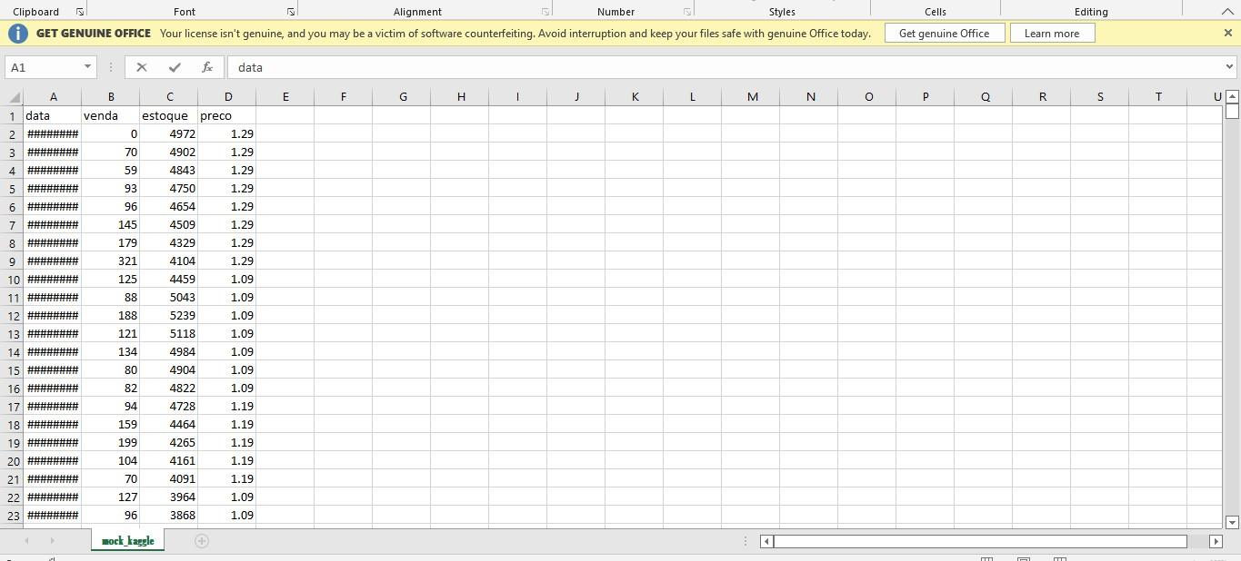

**AFTER RENAMING:**

